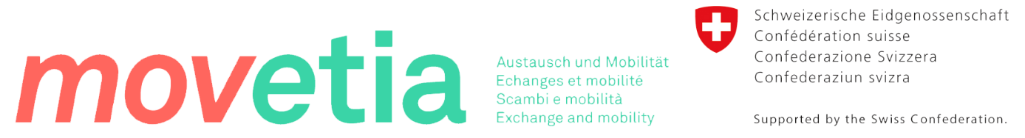

Swiss European Mobility Program (SEMP)
What is SEMP?
The Swiss Programme for Erasmus+ for higher education is called Swiss-European Mobility Programme SEMP. It gives Swiss higher education institutions the possibility to support students as well as teaching and administrative staff doing a study-, training- or teaching-mobility in Europe with funding.
Due to the results of the federal vote in 2014, negotiations between Switzerland and the EU regarding participation in the Erasmus program have been suspended. To ensure the continuity of mobility activities with the Erasmus+ program countries, the Swiss government decided to develop an interim solution for Erasmus+ supported by Swiss funding. This means that the Swiss government provides the funding for incoming and outgoing students, lecturers and staff. The Interim Solution for Erasmus+ for Higher Education is called Swiss-European Mobility Program (SEMP) and follows the precepts of Erasmus+.
Student exchange with partner universities will continue in the framework of the SEMP via bilateral exchange agreements. The conditions for participation in SEMP derive from those of the former Erasmus program.

Mobility Grants and Financial Info:
Outgoing exchange students pay their regular tuition at İstanbul Medipol University and apply the tuition fee waiver at the host institution. Exchange students will be responsible of their personal expenses and living costs while studying abroad. Grants (all outgoing and incoming students) are paid by Switzerland via Movetia. Movetia is the Swiss agency for exchange and mobility. It is sponsored by the Swiss Foundation for the Promotion of Exchanges and Mobility (SFAM).
Please note that availability of the funding can not be guaranteed by our university since SEMP funding is administrated by the Swiss side.
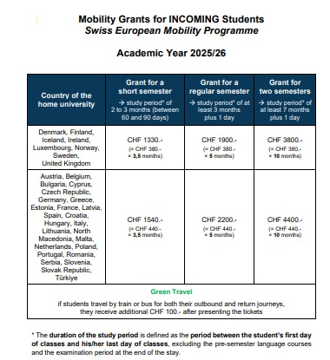

Application & Selection
Who is Eligible to Apply?
SEMP (Swiss Institutions) applications and placements are evaluated under Erasmus + Exchange Program. Each Fall Semester, İstanbul Medipol University Erasmus Office conducts information and sends informative emails to communicate the most up-to-date information about exchange programs and welcomes applications within the announced period.
The recommended exchange semester for Medipol undergraduate students is typically the third year of their studies. We are not suggested to apply the student exchange programs during their last term prior to graduation. First year students who have completed at least 60 credits with a CGPA 2.50 or above are eligible to apply for SEMP exchange program. Upon submitting the application, eligible students will be interviewed by the Erasmus faculty coordinator and Erasmus Office reprasantative.
Placed applicants will be officially nominated by İstanbul Medipol Erasmus Office to the host institutions. After then, students will apply directly to the host institution as an exchange student. Nominees are responsible of following the deadlines, visa process, housing reservations, health insurance and etc. Students must demonstrate sufficient level of language proficiency in line with the requirements of partner institutions.
Upon receiving the acceptance letter from the host institution, students must apply for a student visa. While the student visa application process is solely the responsibility of the applicant, we will provide visa support letter for candidates.
Quota
University name: Université de Genève – CH GENEVE01

Student Mobility for Studies
Subject area [ISCED] |  | Level |  |  | Country |  | Total Numbers
Code | Name | Bachelor | Master | Doctoral | From | To | Students | Months
0312 | International Relations | x |  |  | CH | TR | 2 | 5(=10)
0312 | International Relations | x |  |  | TR | CH | 2 | 5(=10)
0312 | Political sciences | x |  |  | CH | TR | 4 | 5(=20)
0312 | Political sciences | x |  |  | TR | CH | 4 | 5(=20)
0313 | Psychology | x |  |  | CH | TR | 2 | 5(=10)
0313 | Psychology | x |  |  | TR | CH | 2 | 5(=10)

Process for SEMP Students
Before Exchange:
• Application form
•Interview with the Medipol Erasmus Faculty Coordinator and Erasmus Office Jury
•Partner Institutions’ Application Package
•Finalizing the Learning Agreement
•Language Proficiency Document
During Exchange:
•Receive approval from the Medipol Erasmus Faculty Coordinator for the course changes.
After Exchange:
- Transcript of Records of the host institution. (They are usually directly sent by the partner institutions.)
- Certificate of Attendance
- Credits succesfully obtained at the partner institution are transfered to Medipol upon return.

Additional compulsory mobility documents can be required by the receiving Swiss institution. These may include the following:
1. Declaration of Honour: Signed by the students. With this document, the end beneficiary confirms that he/she has received the funding and will use it appropriately and, if the stay is discontinued, will make a reimbursement.
2. Learning Agreement: Agreement among students, home and host university. Essential and integral part of the mobility, ensures accreditation of the study achievements made abroad.
3. Final Report: Duty of the end beneficiaries to submit report to the home university after the end of the period spent abroad. Provides information about the quality and experiences and is used for statistical purposes. Own format must contain all information requested in the Movetia template.
Cancellation
To cancel your application after submitting the Commitment Letter, you need to submit the cancelation petition to İstanbul Medipol Erasmus Office.

More Info on Swiss Mobility
For more information please visit:
https://www.movetia.ch/en/programmes/europe/swiss-programme-for-erasmus/higher-education/mobility

Medipol Contact: erasmus@medipol.edu.tr

